***This is a bonus Web chapter

CHAPTER 46

Remote Method Invocation

Objectives

- To explain how RMI works (§46.2).
- To describe the process of developing RMI applications (§46.3).
- To distinguish between RMI and socket-level programming (§46.4).
- To develop three-tier applications using RMI (§46.5).
- To use callbacks to develop interactive applications (§46.6).

46.1 Introduction
Remote Method Invocation (RMI) provides a framework for building distributed Java systems. Using RMI, a Java object on one system can invoke a method in an object on another system on the network. A distributed Java system can be defined as a collection of cooperative distributed objects on the network. In this chapter, you will learn how to use RMI to create useful distributed applications.

46.2 RMI Basics
RMI is the Java Distributed Object Model for facilitating communications among distributed objects. RMI is a higher-level API built on top of sockets. Socket-level programming allows you to pass data through sockets among computers. RMI enables you also to invoke methods in a remote object. Remote objects can be manipulated as if they were residing on the local host. The transmission of data among different machines is handled by the JVM transparently.

<Side Remark: client>
<Side Remark: server>
In many ways, RMI is an evolution of the client/server architecture. A client is a component that issues requests for services, and a server is a component that delivers the requested services. Like the client/server architecture, RMI maintains the notion of clients and servers, but the RMI approach is more flexible.

- An RMI component can act as both a client and a server, depending on the scenario in question.
- An RMI system can pass functionality from a server to a client, and vice versa. Typically a client/server system only passes data back and forth between server and client.

46.2.1 How Does RMI Work?
<Side Remark: local object>
<Side Remark: remote object>
All the objects you have used before this chapter are called local objects. Local objects are accessible only within the local host. Objects that are accessible from a remote host are called remote objects. For an object to be invoked remotely, it must be defined in a Java interface accessible to both the server and the client. Furthermore, the interface must extend the java.rmi.Remote interface. Like the java.io.Serializable interface, java.rmi.Remote is a marker interface that contains no constants or methods. It is used only to identify remote objects.
The key components of the RMI architecture are listed below (see Figure 46.1):
- Server object interface: A subinterface of java.rmi.Remote that defines the methods for the server object.
- Server class: A class that implements the remote object interface.
- Server object: An instance of the server class.
- RMI registry: A utility that registers remote objects and provides naming services for locating objects.
- Client program: A program that invokes the methods in the remote server object.
- Server stub: An object that resides on the client host and serves as a surrogate for the remote server object.
- Server skeleton: An object that resides on the server host and communicates with the stub and the actual server object.

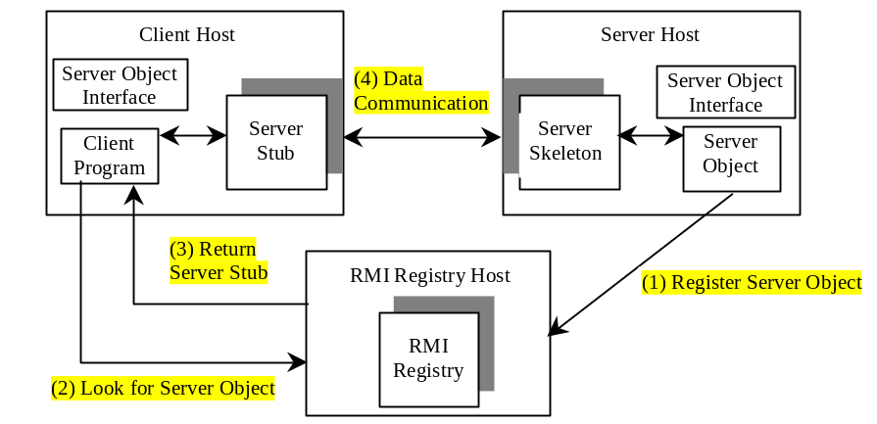
Figure 46.1
Java RMI uses a registry to provide naming services for remote objects, and uses the stub and the skeleton to facilitate communications between client and server.
RMI works as follows:
- A server object is registered with the RMI registry.
- A client looks through the RMI registry for the remote object.
- Once the remote object is located, its stub is returned in the client.
- The remote object can be used in the same way as a local object. Communication between the client and the server is handled through the stub and the skeleton.

<Side Remark: stub>
<Side Remark: skeleton>
The implementation of the RMI architecture is complex, but the good news is that RMI provides a mechanism that liberates you from writing the tedious code for handling parameter passing and invoking remote methods. The basic idea is to use two helper classes known as the stub and the skeleton for handling communications between client and server.

The stub and the skeleton are automatically generated. The stub resides on the client machine. It contains all the reference information the client needs to know about the server object. When a client invokes a method on a server object, it actually invokes a method that is encapsulated in the stub. The stub is responsible for sending parameters to the server and for receiving the result from the server and returning it to the client.

The skeleton communicates with the stub on the server side. The skeleton receives parameters from the client, passes them to the server for execution, and returns the result to the stub.

46.2.2 Passing Parameters
When a client invokes a remote method with parameters, passing the parameters is handled by the stub and the skeleton. Obviously, invoking methods in a remote object on a server is very different from invoking methods in a local object on a client, since the remote object is in a different address space on a separate machine. Let us consider three types of parameters:

<Side Remark: primitive type>
- Primitive data types, such as char, int, double, or boolean, are passed by value like a local call.
<Side Remark: local object>
- Local object types, such as java.lang.String, are also passed by value, but this is completely different from passing an object parameter in a local call. In a local call, an object parameter’s reference is passed, which corresponds to the memory address of the object. In a remote call, there is no way to pass the object reference, because the address on one machine is meaningless to a different JVM. Any object can be used as a parameter in a remote call as long as it is serializable. The stub serializes the object parameter and sends it in a stream across the network. The skeleton deserializes the stream into an object.
<Side Remark: remote object>
- Remote object types are passed differently from local objects. When a client invokes a remote method with a parameter of a remote object type, the stub of the remote object is passed. The server receives the stub and manipulates the parameter through it. Passing remote objects will be discussed in §46.6, “RMI Callbacks.”

46.2.3 RMI Registry
How does a client locate the remote object? The RMI registry provides the registry services for the server to register the object and for the client to locate the object.

You can use several overloaded static getRegistry() methods in the LocateRegistry class to return a reference to a Registry, as shown in Figure 46.2. Once a Registry is obtained, you can bind an object with a unique name in the registry using the bind or rebind method or locate an object using the lookup method, as shown in Figure 46.3.

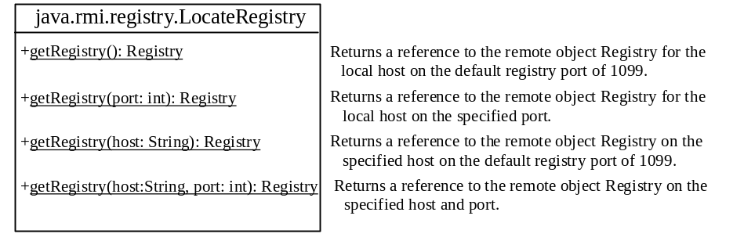
Figure 46.2
The LocateRegistry class provides the methods for obtaining a registry on a host.

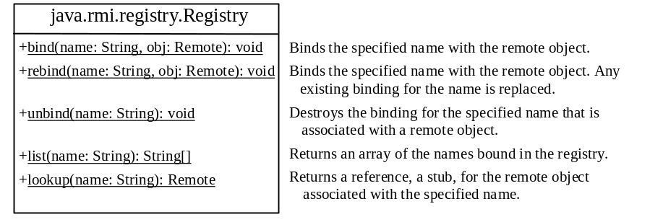
Figure 46.3
The Registry class provides the methods for binding and obtaining references to remote objects in a remote object registry.

46.3 Developing RMI Applications
Now that you have a basic understanding of RMI, you are ready to write simple RMI applications. The steps in developing an RMI application are shown in Figure 46.4 and listed below.

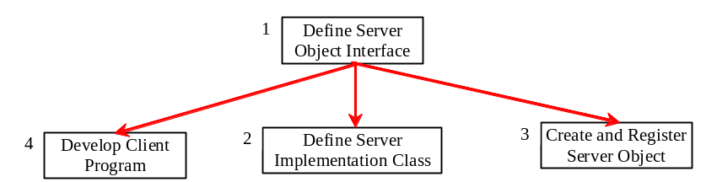
Figure 46.4
The steps in developing an RMI application.

- Define a server object interface that serves as the contract between the server and its clients, as shown in the following outline:

public interface ServerInterface extends Remote {
public void service1(...) throws RemoteException;
// Other methods
}

A server object interface must extend the java.rmi.Remote interface.

- Define a class that implements the server object interface, as shown in the following outline:

public class ServerInterfaceImpl extends UnicastRemoteObject
implements ServerInterface {
public void service1(...) throws RemoteException {
// Implement it
}
// Implement other methods
}

The server implementation class must extend the java.rmi.server.UnicastRemoteObject class. The UnicastRemoteObject class provides support for point-to-point active object references using TCP streams.

- Create a server object from the server implementation class and register it with an RMI registry:

ServerInterface server = new ServerInterfaceImpl(...);
Registry registry = LocateRegistry.getRegistry();
registry.rebind("RemoteObjectName", server);

- Develop a client that locates a remote object and invokes its methods, as shown in the following outline:

Registry registry = LocateRegistry.getRegistry(host);
ServerInterface server = (ServerInterfaceImpl)
registry.lookup("RemoteObjectName");
server.service1(...);

The example that follows demonstrates the development of an RMI application through these steps.

46.3.1 Example: Retrieving Student Scores from an RMI Server
This example creates a client that retrieves student scores from an RMI server. The client, shown in Figure 46.5, displays the score for the specified name.
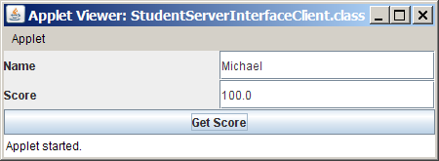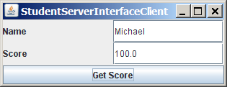
(a) Running as applet. (b) Running as application.
Figure 46.5
You can get the score by entering a student name and clicking the Get Score button.

1. Create a server interface named StudentServerInterface in Listing 46.1. The interface tells the client how to invoke the server's findScore method to retrieve a student score.

Listing 46.1 StudentServerInterface.java
<Side Remark line 3: subinterface>
<Side Remark line 9: server method>
import java.rmi.*;

public interface StudentServerInterface extends Remote {
/**
* Return the score for the specified name
* @param name the student name
* @return a double score or –1 if the student is not found
*/
public double findScore(String name) throws RemoteException;
}

Any object that can be used remotely must be defined in an interface that extends the java.rmi.Remote interface (line 3). StudentServerInterface, extending Remote, defines the findScore method that can be remotely invoked by a client to find a student's score. Each method in this interface must declare that it may throw a java.rmi.RemoteException (line 9). Therefore your client code that invokes this method must be prepared to catch this exception in a try-catch block.

2. Create a server implementation named StudentServerInterfaceImpl (Listing 46.2) that implements StudentServerInterface. The findScore method returns the score for a specified student. It returns -1 if the score is not found.

Listing 46.2 StudentServerInterfaceImpl.java
<Side Remark line 8: hash map>
<Side Remark line 17: store score>
<Side Remark line 24: get score>

import java.rmi.*;
import java.rmi.server.*;
import java.util.*;

public class StudentServerInterfaceImpl
extends UnicastRemoteObject
implements StudentServerInterface {
// Stores scores in a map indexed by name
private HashMap<String, Double> scores =
new HashMap<String, Double>();

public StudentServerInterfaceImpl() throws RemoteException {
initializeStudent();
}

/** Initialize student information */
protected void initializeStudent() {
scores.put("John", new Double(90.5));
scores.put("Michael", new Double(100));
scores.put("Michelle", new Double(98.5));
}

/** Implement the findScore method from the
* Student interface */
public double findScore(String name) throws RemoteException {
Double d = (Double)scores.get(name);

if (d == null) {
System.out.println("Student " + name + " is not found ");
return -1;
}
else {
System.out.println("Student " + name + "\'s score is "
+ d.doubleValue());
return d.doubleValue();
}
}
}

The StudentServerInterfaceImpl class implements StudentServerInterface. This class must also extend the java.rmi.server.RemoteServer class or its subclass. RemoteServer is an abstract class that defines the methods needed to create and export remote objects. Often its subclass java.rmi.server.UnicastRemoteObject is used (line 6). This subclass implements all the abstract methods defined in RemoteServer.

StudentServerInterfaceImpl implements the findScore method (lines 25-37) defined in StudentServerInterface. For simplicity, three students, John, Michael, and Michelle, and their corresponding scores are stored in an instance of java.util.HashMap named scores. HashMap is a concrete class of the Map interface in the Java Collections Framework, which makes it possible to search and retrieve a value using a key. Both values and keys are of Object type. The findScore method returns the score if the name is in the hash map, and returns -1 if the name is not found.

3. Create a server object from the server implementation and register it with the RMI server (Listing 46.3).

Listing 46.3 RegisterWithRMIServer.java
<Side Remark line 7: server object>
<Side Remark line 8: registry reference>
<Side Remark line 9: register>
import java.rmi.registry.*;

public class RegisterWithRMIServer {
/** Main method */
public static void main(String[] args) {
try {
StudentServerInterface obj =
new StudentServerInterfaceImpl();
Registry registry = LocateRegistry.getRegistry();
registry.rebind("StudentServerInterfaceImpl", obj);
System.out.println("Student server " + obj + " registered");
}
catch (Exception ex) {
ex.printStackTrace();
}
}
}

RegisterWithRMIServer contains a main method, which is responsible for starting the server. It performs the following tasks: (1) create a server object (line 8); (2) obtain a reference to the RMI registry (line 9), and (3) register the object in the registry (line 10).

4. Create a client as an applet named StudentServerInterfaceClient in Listing 46.4. The client locates the server object from the RMI registry and uses it to find the scores.

Listing 46.4 StudentServerInterfaceClient.java
<Side Remark line 9: remote object>
<Side Remark line 11: standalone?>
<Side Remark line 19: initialize RMI>
<Side Remark line 31: register listener>
<Side Remark line 33: get score>
<Side Remark line 61: locate student>
<Side Remark line 71: main method>
<Side Remark line 74: standalone>
import javax.swing.*;
import java.awt.*;
import java.awt.event.*;
import java.rmi.registry.LocateRegistry;
import java.rmi.registry.Registry;

public class StudentServerInterfaceClient extends JApplet {
// Declare a Student instance
private StudentServerInterface student;

private boolean isStandalone; // Is applet or application

private JButton jbtGetScore = new JButton("Get Score");
private JTextField jtfName = new JTextField();
private JTextField jtfScore = new JTextField();

public void init() {
// Initialize RMI
initializeRMI();

JPanel jPanel1 = new JPanel();
jPanel1.setLayout(new GridLayout(2, 2));
jPanel1.add(new JLabel("Name"));
jPanel1.add(jtfName);
jPanel1.add(new JLabel("Score"));
jPanel1.add(jtfScore);

add(jbtGetScore, BorderLayout.SOUTH);
add(jPanel1, BorderLayout.CENTER);

jbtGetScore.addActionListener(new ActionListener() {
public void actionPerformed(ActionEvent evt) {
getScore();
}
});
}

private void getScore() {
try {
// Get student score
double score = student.findScore(jtfName.getText().trim());

// Display the result
if (score < 0)
jtfScore.setText("Not found");
else
jtfScore.setText(new Double(score).toString());
}
catch(Exception ex) {
ex.printStackTrace();
}
}

/** Initialize RMI */
protected void initializeRMI() {
String host = "";
if (!isStandalone) host = getCodeBase().getHost();

try {
Registry registry = LocateRegistry.getRegistry(host);
student = (StudentServerInterface)
registry.lookup("StudentServerInterfaceImpl");
System.out.println("Server object " + student + " found");
}
catch(Exception ex) {
System.out.println(ex);
}
}

/** Main method */
public static void main(String[] args) {
StudentServerInterfaceClient applet =
new StudentServerInterfaceClient();
applet.isStandalone = true;
JFrame frame = new JFrame();
frame.setTitle("StudentServerInterfaceClient");
frame.add(applet, BorderLayout.CENTER);
frame.setSize(250, 150);
applet.init();
frame.setLocationRelativeTo(null);
frame.setVisible(true);
frame.setDefaultCloseOperation(3);
}
}

StudentServerInterfaceClient invokes the findScore method on the server to find the score for a specified student. The key method in StudentServerInterfaceClient is the initializeRMI method (lines 55-68), which is responsible for locating the server stub.

The initializeRMI() method treats standalone applications differently from applets. The host name should be the name where the applet is downloaded. It can be obtained using the Applet's getCodeBase().getHost() (line 52). For standalone applications, the host name should be specified explicitly.

The lookup(String name) method (line 62) returns the remote object with the specified name. Once a remote object is found, it can be used just like a local object. The stub and the skeleton are used behind the scenes to make the remote method invocation work.

5. Follow the steps below to run this example.

5.1. Start the RMI Registry by typing "start rmiregistry" at a DOS prompt from the book directory. By default, the port number 1099 is used by rmiregistry. To use a different port number, simply type the command "start rmiregistry portnumber" at a DOS prompt.

5.2. Start the server RegisterWithRMIServer using the following command at C:\book directory:

C:\book>java RegisterWithRMIServer

5.3. Run the client StudentServerInterfaceClient as an application. A sample run of the application is shown in Figure 46.5(b).

5.4. Run the client StudentServerInterfaceClient.html from the appletviewer. A sample run is shown in Figure 46.5(a).

NOTE: You must start rmiregistry from the directory where you will run the RMI server, as shown in Figure 46.6. Otherwise, you will receive the error ClassNotFoundException on StudentServerInterfaceImpl_Stub.

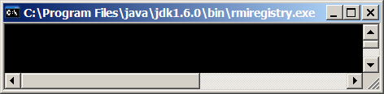
RMI registry
Start RMI registry
Start RMI server
Run RMI client

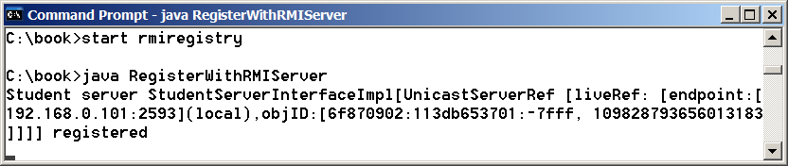

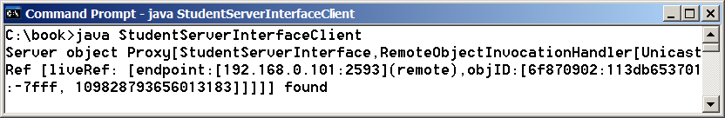
Figure 46.6
To run an RMI program, first start the RMIRegistry, then register the server object with the registry. The client locates it from the registry.

NOTE: Server, registry, and client can be on three different machines. If you run the client and the server on separate machines, you need to place StudentServerInterface on both machines. If you deploy the client as an applet, place all client files on the registry host.
CAUTION: If you modify the remote object implementation class, you need to restart the server class to reload the object to the RMI registry. In some old versions of rmiregistry, you may have to restart rmiregistry.

46.4 RMI vs. Socket-Level Programming
RMI enables you to program at a higher level of abstraction. It hides the details of socket server, socket, connection, and sending or receiving data. It even implements a multithreading server under the hood, whereas with socket-level programming you have to explicitly implement threads for handling multiple clients.

RMI applications are scalable and easy to maintain. You can change the RMI server or move it to another machine without modifying the client program except for resetting the URL to locate the server. (To avoid resetting the URL, you can modify the client to pass the URL as a command-line parameter.) In socket-level programming, a client operation to send data requires a server operation to read it. The implementation of client and server at the socket level is tightly synchronized.

RMI clients can directly invoke the server method, whereas socket-level programming is limited to passing values. Socket-level programming is very primitive. Avoid using it to develop client/server applications. As an analogy, socket-level programming is like programming in assembly language, while RMI programming is like programming in a high-level language.

46.5 Developing Three-Tier Applications Using RMI
Three-tier applications have gained considerable attention in recent years, largely because of the demand for more scalable and load-balanced systems to replace traditional two-tier client/server database systems. A centralized database system does not just handle data access, it also processes the business rules on data. Thus, a centralized database is usually heavily loaded, because it requires extensive data manipulation and processing. In some situations, data processing is handled by the client and business rules are stored on the client side. It is preferable to use a middle tier as a buffer between client and database. The middle tier can be used to apply business logic and rules, and to process data to reduce the load on the database.

A three-tier architecture does more than just reduce the processing load on the server. It also provides access to multiple network sites. This is especially useful to Java applets that need to access multiple databases on different servers, since an applet can connect only with the server from which it is downloaded.

To demonstrate, let us rewrite the example in §46.3.1, “Example: Retrieving Student Scores from an RMI Server,” to find scores stored in a database rather than a hash map. In addition, the system is capable of blocking a client from accessing a student who has not given the university permission to publish his/her score. An RMI component is developed to serve as a middle tier between client and database; it sends a search request to the database, processes the result, and returns an appropriate value to the client.

For simplicity, this example reuses the StudentServerInterface interface and StudentServerInterfaceClient class from §46.3.1 with no modifications. All you have to do is to provide a new implementation for the server interface and create a program to register the server with the RMI. Here are the steps to complete the program:

- Store the scores in a database table named Score that contains three columns: name, score, and permission. The permission value is 1 or 0, which indicates whether the student has given the university permission to release his/her grade. The following is the statement to create the table and insert three records:

create table Scores (name varchar(20),
score number, permission number);

insert into Scores values ('John', 90.5, 1);
insert into Scores values ('Michael', 100, 1);
insert into Scores values ('Michelle', 100, 0);

- Create a new server implementation named Student3TierImpl in Listing 46.5. The server retrieves a record from the Scores table, processes the retrieved information, and sends the result back to the client.

Listing 46.5 Student3TierImpl.java
<Side Remark line 14: initialize db>
<Side Remark line 31: load driver>
<Side Remark line 39: connect db>
<Side Remark line 43: prepare statement>
<Side Remark line 58: set name>
<Side Remark line 61: execute SQL>
<Side Remark line 66: get score>
import java.rmi.*;
import java.rmi.server.*;
import java.sql.*;

public class Student3TierImpl extends UnicastRemoteObject
implements StudentServerInterface {
// Use prepared statement for querying DB
private PreparedStatement pstmt;

/** Constructs Student3TierImpl object and exports it on
* default port.
*/
public Student3TierImpl() throws RemoteException {
initializeDB();
}

/** Constructs Student3TierImpl object and exports it on
* specified port.
* @param port The port for exporting
*/
public Student3TierImpl(int port) throws RemoteException {
super(port);
initializeDB();
}

/** Load JDBC driver, establish connection and
* create statement */
protected void initializeDB() {
try {
// Load the JDBC driver
// Class.forName("oracle.jdbc.driver.OracleDriver");
Class.forName("com.mysql.jdbc.Driver ");

System.out.println("Driver registered");

// Establish connection
/*Connection conn = DriverManager.getConnection
("jdbc:oracle:thin:@drake.armstrong.edu:1521:orcl",
"scott", "tiger"); */
Connection conn = DriverManager.getConnection
"jdbc:mysql://localhost/javabook" , "scott", "tiger");
System.out.println("Database connected");

// Create a prepared statement for querying DB
pstmt = conn.prepareStatement(
"select * from Scores where name = ?");
}
catch (Exception ex) {
System.out.println(ex);
}
}

/** Return the score for specified the name
* Return -1 if score is not found.
*/
public double findScore(String name) throws RemoteException {
double score = -1;
try {
// Set the specified name in the prepared statement
pstmt.setString(1, name);

// Execute the prepared statement
ResultSet rs = pstmt.executeQuery();

// Retrieve the score
if (rs.next()) {
if (rs.getBoolean(3))
score = rs.getDouble(2);
}
}
catch (SQLException ex) {
System.out.println(ex);
}

System.out.println(name + "\'s score is " + score);
return score;
}
}

Student3TierImpl is similar to StudentServerInterfaceImpl in §46.3.1 except that the Student3TierImpl class finds the score from a JDBC data source instead from a hash map.

The table named Scores consists of three columns, name, score, and permission, where the latter indicates whether the student has given permission to show his/her score. Since SQL does not support a boolean type, permission is defined as a number whose value of 1 indicates true and of 0 indicates false.

The initializeDB() method (lines 28-42) establishes connections with the database and creates a prepared statement for processing the query.

The findScore method (lines 47-68) sets the name in the prepared statement, executes the statement, processes the result, and returns the score for a student whose permission is true.

- Write a main method in the class RegisterStudent3TierServer (Listing 46.6) that registers the server object using StudentServerInterfaceImpl, the same name as in Listing 46.2, so that you can use StudentServerInterfaceClient, created in §46.3.1, to test the server.

Listing 46.6 RegisterStudent3TierServer.java
<Side Remark line 7: registry on localhost>
<Side Remark line 8: register server object>
import java.rmi.registry.*;

public class RegisterStudent3TierServer {
public static void main(String[] args) {
try {
StudentServerInterface obj = new Student3TierImpl();
Registry registry = LocateRegistry.getRegistry();
registry.rebind("StudentServerInterfaceImpl", obj);
System.out.println("Student server " + obj + " registered");
} catch (Exception ex) {
ex.printStackTrace();
}
}
}

4. Follow the steps below to run this example.
4.1. Start RMI Registry by typing "start rmiregistry" at a DOS prompt from the book directory.

4.2. Start the server RegisterStudent3TierServer using the following command at the C:\book directory:

C:\book>java RegisterStudent3TierServer

4.3. Run the client StudentServerInterfaceClient as an application or applet. A sample run is shown in Figure 46.6.

46.6 RMI Callbacks

In a traditional client/server system, a client sends a request to a server, and the server processes the request and returns the result to the client. The server cannot invoke the methods on a client. One important benefit of RMI is that it supports callbacks, which enable the server to invoke methods on the client. With the RMI callback feature, you can develop interactive distributed applications.

In §30.9, “Case Studies: Distributed TicTacToe Games,” you developed a distributed TicTacToe game using stream socket programming. The example that follows demonstrates the use of the RMI callback feature to develop an interactive TicTacToe game.

All the examples you have seen so far in this chapter have simple behaviors that are easy to model with classes. The behavior of the TicTacToe game is somewhat complex. To create the classes to model the game, you need to study and understand it and distribute the process appropriately between client and server.

Clearly the client should be responsible for handling user interactions, and the server should coordinate with the client. Specifically, the client should register with the server, and the server can take two and only two players. Once a client makes a move, it should notify the server; the server then notifies the move to the other player. The server should determine the status of the game—that is, whether it has been won or drawn—and notify the players. The server should also coordinate the turns—that is, which client has the turn at a given time. The ideal approach for notifying a player is to invoke a method in the client that sets appropriate properties in the client or sends messages to a player. Figure 46.7 illustrates the relationship between clients and server.
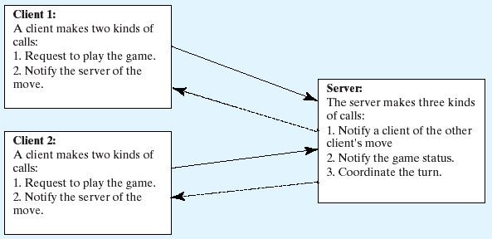
Figure 46.7
The server coordinates the activities with the clients.

All the calls a client makes can be encapsulated in one remote interface named TicTacToe (Listing 46.7), and all the calls the server invokes can be defined in another interface named CallBack (Listing 46.8). These two interfaces are defined as follows:

Listing 46.7 TicTacToeInterface.java

<Side Remark line 3: subinterface>
<Side Remark line 9: server method>
<Side Remark line 12: server method>

import java.rmi.*;

public interface TicTacToeInterface extends Remote {
/**
* Connect to the TicTacToe server and return the token.
* If the returned token is ' ', the client is not connected to
* the server
*/
public char connect(CallBack client) throws RemoteException;

/** A client invokes this method to notify the server of its move*/
public void myMove(int row, int column, char token)
throws RemoteException;
}
Listing 46.8 CallBack.java

<Side Remark line 3: subinterface>
<Side Remark line 5: server method>
<Side Remark line 8: server method>
<Side Remark line 12: server method>

import java.rmi.*;

public interface CallBack extends Remote {
/** The server notifies the client for taking a turn */
public void takeTurn(boolean turn) throws RemoteException;

/** The server sends a message to be displayed by the client */
public void notify(java.lang.String message)
throws RemoteException;

/** The server notifies a client of the other player's move */
public void mark(int row, int column, char token)
throws RemoteException;
}

What does a client need to do? The client interacts with the player. Assume that all the cells are initially empty, and that the first player takes the X token and the second player the O token. To mark a cell, the player points the mouse to the cell and clicks it. If the cell is empty, the token (X or O) is displayed. If the cell is already filled, the player's action is ignored.

From the preceding description, it is obvious that a cell is a GUI object that handles mouse-click events and displays tokens. The candidate for such an object could be a button or a panel. Panels are more flexible than buttons. The token (X or O) can be drawn on a panel in any size, but it can be displayed only as a label on a button.

Let Cell be a subclass of JPanel. You can declare a 3  3 grid to be an array Cell[][] cell = new Cell[3][3] for modeling the game. How do you know the state of a cell (marked or not)? You can use a property named marked of the boolean type in the Cell class. How do you know whether the player has a turn? You can use a property named myTurn of boolean. This property (initially false) can be set by the server through a callback.

The Cell class is responsible for drawing the token when an empty cell is clicked, so you need to write the code for listening to the MouseEvent and for painting the shape for tokens X and O. To determine which shape to draw, introduce a variable named marker of the char type. Since this variable is shared by all the cells in a client, it is preferable to declare it in the client and to declare the Cell class as an inner class of the client so that this variable will be accessible to all the cells.

Now let us turn our attention to the server side. What does the server need to do? The server needs to implement TicTacToeInterface and notify the clients of the game status. The server has to record the moves in the cells and check the status every time a player makes a move. The status information can be kept in a 3  3 array of char. You can implement a method named isFull() to check whether the board is full and a method named isWon(token) to check whether a specific player has won.

Once a client is connected to the server, the server notifies the client which token to use—that is, X for the first client and O for the second. Once a client notifies the server of its move, the server checks the game status and notifies the clients.

Now the most critical question is how the server notifies a client. You know that a client invokes a server method by creating a server stub on the client side. A server cannot directly invoke a client, because the client is not declared as a remote object. The CallBack interface was created to facilitate the server's callback to the client. In the implementation of CallBack, an instance of the client is passed as a parameter in the constructor of CallBack. The client creates an instance of CallBack and passes its stub to the server, using a remote method named connect() defined in the server. The server then invokes the client's method through a CallBack instance. The triangular relationship of client, CallBack implementation, and server is shown in Figure 46.8.

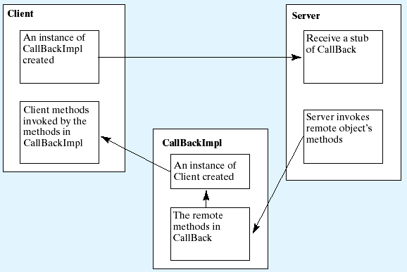
Figure 46.8
The server receives a CallBack stub from the client and invokes the remote methods defined in the CallBack interface, which can invoke the methods defined in the client.
Here are the steps to complete the example.

- Create TicTacToeImpl.java (Listing 46.9) to implement TicTacToeInterface. Add a main method in the program to register the server with the RMI.

Listing 46.9 TicTacToeImpl.java
<Side Remark line 9: call back objects>
<Side Remark line 34: implement connect>
<Side Remark line 58: implement myMove>
<Side Remark line 101: isWon>
<Side Remark line 124: isFull>
<Side Remark line 137: register object>
import java.rmi.*;
import java.rmi.server.*;
import java.rmi.registry.*;
import java.rmi.registry.*;

public class TicTacToeImpl extends UnicastRemoteObject
implements TicTacToeInterface {
// Declare two players, used to call players back
private CallBack player1 = null;
private CallBack player2 = null;

// board records players' moves
private char[][] board = new char[3][3];

/** Constructs TicTacToeImpl object and exports it on default port.
*/
public TicTacToeImpl() throws RemoteException {
super();
}

/** Constructs TicTacToeImpl object and exports it on specified
* port.
* @param port The port for exporting
*/
public TicTacToeImpl(int port) throws RemoteException {
super(port);
}

/**
* Connect to the TicTacToe server and return the token.
* If the returned token is ' ', the client is not connected to
* the server
*/
public char connect(CallBack client) throws RemoteException {
if (player1 == null) {
// player1 (first player) registered
player1 = client;
player1.notify("Wait for a second player to join");
return 'X';
}
else if (player2 == null) {
// player2 (second player) registered
player2 = client;
player2.notify("Wait for the first player to move");
player2.takeTurn(false);
player1.notify("It is my turn (X token)");
player1.takeTurn(true);
return 'O';
}
else {
// Already two players
client.notify("Two players are already in the game");
return ' ';
}
}

/** A client invokes this method to notify the server of its move*/
public void myMove(int row, int column, char token)
throws RemoteException {
// Set token to the specified cell
board[row][column] = token;

// Notify the other player of the move
if (token == 'X')
player2.mark(row, column, 'X');
else
player1.mark(row, column, 'O');

// Check if the player with this token wins
if (isWon(token)) {
if (token == 'X') {
player1.notify("I won!");
player2.notify("I lost!");
player1.takeTurn(false);
}
else {
player2.notify("I won!");
player1.notify("I lost!");
player2.takeTurn(false);
}
}
else if (isFull()) {
player1.notify("Draw!");
player2.notify("Draw!");
}
else if (token == 'X') {
player1.notify("Wait for the second player to move");
player1.takeTurn(false);
player2.notify("It is my turn, (O token)");
player2.takeTurn(true);
}
else if (token == 'O') {
player2.notify("Wait for the first player to move");
player2.takeTurn(false);
player1.notify("It is my turn, (X token)");
player1.takeTurn(true);
}
}

/** Check if a player with the specified token wins */
public boolean isWon(char token) {
for (int i = 0; i < 3; i++)
if ((board[i][0] == token) && (board[i][1] == token)
&& (board[i][2] == token))
return true;

for (int j = 0; j < 3; j++)
if ((board[0][j] == token) && (board[1][j] == token)
&& (board[2][j] == token))
return true;

if ((board[0][0] == token) && (board[1][1] == token)
&& (board[2][2] == token))
return true;

if ((board[0][2] == token) && (board[1][1] == token)
&& (board[2][0] == token))
return true;

return false;
}

/** Check if the board is full */
public boolean isFull() {
for (int i = 0; i < 3; i++)
for (int j = 0; j < 3; j++)
if (board[i][j] == '\u0000')
return false;

return true;
}

public static void main(String[] args) {
try {
TicTacToeInterface obj = new TicTacToeImpl();
Registry registry = LocateRegistry.getRegistry();
registry.rebind("TicTacToeImpl", obj);
System.out.println("Server " + obj + " registered");
}
catch (Exception ex) {
ex.printStackTrace();
}
}
}

- Create CallBackImpl.java (Listing 46.10) to implement the CallBack interface.

Listing 46.10 CallBackImpl.java

<Side Remark line 15: implement>
<Side Remark line 20: implement>
<Side Remark line 25: implement>

import java.rmi.*;
import java.rmi.server.*;

public class CallBackImpl extends UnicastRemoteObject
implements CallBack {
// The client will be called by the server through callback
private TicTacToeClientRMI thisClient;

/** Constructor */
public CallBackImpl(Object client) throws RemoteException {
thisClient = (TicTacToeClientRMI)client;
}

/** The server notifies the client for taking a turn */
public void takeTurn(boolean turn) throws RemoteException {
thisClient.setMyTurn(turn);
}

/** The server sends a message to be displayed by the client */
public void notify(String message) throws RemoteException {
thisClient.setMessage(message);
}

/** The server notifies a client of the other player's move */
public void mark(int row, int column, char token)
throws RemoteException {
thisClient.mark(row, column, token);
}
}

- Create an applet TicTacToeClientRMI (Listing 46.11) for interacting with a player and communicating with the server. Enable it to run standalone.

Listing 46.11 TicTacToeClientRMI.java

<Side Remark line 20: server object>
<Side Remark line 33: create UI>
<Side Remark line 58: registry host>
<Side Remark line 62: server object>
<Side Remark line 70: call back>
<Side Remark line 115: register listener>
<Side Remark line 165: standalone>

import java.rmi.*;
import java.awt.*;
import java.awt.event.*;
import javax.swing.*;
import javax.swing.border.*;
import java.rmi.registry.Registry;
import java.rmi.registry.LocateRegistry;

public class TicTacToeClientRMI extends JApplet {
// marker is used to indicate the token type
private char marker;

// myTurn indicates whether the player can move now
private boolean myTurn = false;

// Each cell can be empty or marked as 'O' or 'X'
private Cell[][] cell;

// ticTacToe is the game server for coordinating with the players
private TicTacToeInterface ticTacToe;

// Border for cells and panel
private Border lineBorder =
BorderFactory.createLineBorder(Color.yellow, 1);

private JLabel jlblStatus = new JLabel("jLabel1");
private JLabel jlblIdentification = new JLabel();

boolean isStandalone = false;

/** Initialize the applet */
public void init() {
JPanel jPanel1 = new JPanel();
jPanel1.setBorder(lineBorder);
jPanel1.setLayout(new GridLayout(3, 3, 1, 1));

add(jlblStatus, BorderLayout.SOUTH);
add(jPanel1, BorderLayout.CENTER);
add(jlblIdentification, BorderLayout.NORTH);

// Create cells and place cells in the panel
cell = new Cell[3][3];
for (int i = 0; i < 3; i++)
for (int j = 0; j < 3; j++)
jPanel1.add(cell[i][j] = new Cell(i, j));

try {
initializeRMI();
}
catch (Exception ex) {
ex.printStackTrace();
}
}

/** Initialize RMI */
protected boolean initializeRMI() throws Exception {
String host = "";
if (!isStandalone) host = getCodeBase().getHost();

try {
Registry registry = LocateRegistry.getRegistry(host);
ticTacToe = (TicTacToeInterface) registry.lookup("TicTacToeImpl");
System.out.println("Server object " + ticTacToe + " found");
}
catch (Exception ex) {
System.out.println(ex);
}

// Create callback for use by the server to control the client
CallBackImpl callBackControl = new CallBackImpl(this);

if (
(marker = ticTacToe.connect((CallBack)callBackControl)) != ' ')
{
System.out.println("connected as " + marker + " player.");
jlblIdentification.setText("You are player " + marker);
return true;
}
else {
System.out.println("already two players connected as ");
return false;
}
}

/** Set variable myTurn to true or false */
public void setMyTurn(boolean myTurn) {
this.myTurn = myTurn;
}

/** Set message on the status label */
public void setMessage(String message) {
jlblStatus.setText(message);
}

/** Mark the specified cell using the token */
public void mark(int row, int column, char token) {
cell[row][column].setToken(token);
}

/** Inner class Cell for modeling a cell on the TicTacToe board */
private class Cell extends JPanel {
// marked indicates whether the cell has been used
private boolean marked = false;

// row and column indicate where the cell appears on the board
int row, column;

// The token for the cell
private char token;

/** Construct a cell */
public Cell(final int row, final int column) {
this.row = row;
this.column = column;
addMouseListener(new MouseAdapter() {
public void mouseClicked(MouseEvent e) {
if (myTurn && !marked) {
// Mark the cell
setToken(marker);

// Notify the server of the move
try {
ticTacToe.myMove(row, column, marker);
}
catch (RemoteException ex) {
System.out.println(ex);
}
}
}
});

setBorder(lineBorder);
}

/** Set token on a cell (mark a cell) */
public void setToken(char c) {
token = c;
marked = true;
repaint();
}

/** Paint the cell to draw a shape for the token */
protected void paintComponent(Graphics g) {
super.paintComponent(g);

// Draw the border
g.drawRect(0, 0, getSize().width, getSize().height);

if (token == 'X') {
g.drawLine(10, 10, getSize().width - 10,
getSize().height - 10);
g.drawLine(getSize().width - 10, 10, 10,
getSize().height - 10);
}
else if (token == 'O') {
g.drawOval(10, 10, getSize().width - 20,
getSize().height - 20);
}
}
}

/** Main method */
public static void main(String[] args) {
TicTacToeClientRMI applet = new TicTacToeClientRMI();
applet.isStandalone = true;
applet.init();
applet.start();
JFrame frame = new JFrame();
frame.setDefaultCloseOperation(JFrame.EXIT_ON_CLOSE);
frame.setTitle("TicTacToeClientRMI");
frame.add(applet, BorderLayout.CENTER);
frame.setSize(400, 320);
frame.setVisible(true);
}
}

- Follow the steps below to run this example.
4.1. Start RMI Registry by typing "start rmiregistry" at a DOS prompt from the book directory.
4.2. Start the server TicTacToeImpl using the following command at the C:\book directory:

C:\book>java TicTacToeImpl

Run the client TicTacToeClientRMI as an application or an applet. A sample run is shown in Figure 46.9.

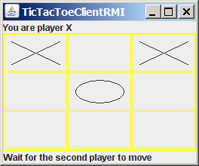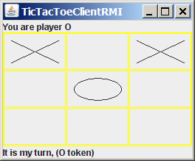
Figure 46.9
Two players play each other through the RMI server.

TicTacToeInterface defines two remote methods, connect(CallBack client) and myMove(int row, int column, char token). The connect method plays two roles: one is to pass a CallBack stub to the server, and the other is to let the server assign a token for the player. The myMove method notifies the server that the player has made a specific move.

The CallBack interface defines three remote methods, takeTurn(boolean turn), notify(String message), and mark(int row, int column, char token). The takeTurn method sets the client's myTurn property to true or false. The notify method displays a message on the client's status label. The mark method marks the client's cell with the token at the specified location.

TicTacToeImpl is a server implementation for coordinating with the clients and managing the game. The variables player1 and player2 are instances of CallBack, each of which corresponds to a client, passed from a client when the client invokes the connect method. The variable board records the moves by the two players. This information is needed to determine the game status. When a client invokes the connect method, the server assigns a token X for the first player and O for the second player, and accepts only two players. You can modify the program to accept additional clients as observers. See Exercise 46.7 for more details.

Once two players are in the game, the server coordinates the turns between them. When a client invokes the myMove method, the server records the move and notifies the other player by marking the other player's cell. It then checks to see whether the player wins or whether the board is full. If neither condition applies and therefore the game continues, the server gives a turn to the other player.

The CallBackImpl implements the CallBack interface. It creates an instance of TicTacToeClientRMI through its constructor. The CallBackImpl relays the server request to the client by invoking the client's methods. When the server invokes the takeTurn method, CallBackImpl invokes the client's setMyTurn() method to set the property myTurn in the client. When the server invokes the notify() method, CallBackImpl invokes the client's setMessage() method to set the message on the client's status label. When the server invokes the mark method, CallBackImpl invokes the client's mark method to mark the specified cell.

TicTacToeClientRMI can run as a standalone application or as an applet. The initializeRMI method is responsible for creating the URL for running as a standalone application or as an applet, for locating the TicTacToeImpl server stub, for creating the CallBack server object, and for connecting the client with the server.

Interestingly, obtaining the TicTacToeImpl stub for the client is different from obtaining the CallBack stub for the server. The TicTacToeImpl stub is obtained by invoking the lookup() method through the RMI registry, and the CallBack stub is passed to the server through the connect method in the TicTacToeImpl stub. It is a common practice to obtain the first stub with the lookup method, but to pass the subsequent stubs as parameters through remote method invocations.

Since the variables myTurn and marker are defined in TicTacToeClientRMI, the Cell class is defined as an inner class within TicTacToeClientRMI in order to enable all the cells in the client to access them. Exercise 46.8 suggests alternative approaches that implement the Cell as a noninner class.

Key Terms

- callback
- RMI registry
- skeleton
- stub

Chapter Summary

- RMI is a high-level Java API for building distributed applications using distributed objects.
- The key idea of RMI is its use of stubs and skeletons to facilitate communications between objects. The stub and skeleton are automatically generated, which relieves programmers of tedious socket-level network programming.
- For an object to be used remotely, it must be defined in an interface that extends the java.rmi.Remote interface.
- In an RMI application, the initial remote object must be registered with the RMI registry on the server side and be obtained using the lookup method through the registry on the client side. Subsequent uses of stubs of other remote objects may be passed as parameters through remote method invocations.
- RMI is especially useful for developing scalable and load-balanced multitier distributed applications.

Test Questions
Do the test questions for this chapter online at www.cs.armstrong.edu/liang/intro9e/test.html.

Review Questions

Sections 46.2-46.3
46.1 How do you define an interface for a remote object?
46.2 Describe the roles of the stub and the skeleton.
46.3 What is java.rmi.Remote? How do you define a server class?
46.4 What is an RMI registry for? How do you create an RMI registry?
46.5 What is the command to start an RMI Registry?
46.6 How do you register a remote object with the RMI registry?
46.7 What is the command to start a custom RMI server?
46.8 How does a client locate a remote object stub through an RMI registry?
46.9 How do you obtain a registry? How do you register a remote object? How do you locate remote object?

Sections 46.4-46.6
46.10 What are the advantages of RMI over socket-level programming?
46.11 Describe how parameters are passed in RMI.
46.12 What is the problem if the connect method in the TicTacToeInterface is defined as

public boolean connect(CallBack client, char token)
throws RemoteException;

or as

public boolean connect(CallBack client, Character token)
throws RemoteException;

46.13 What is callback? How does callback work in RMI?

Programming Exercises

Section 46.3
46.1*
(Limit the number of clients) Modify the example in §46.3.1, “Example: Retrieving Student Scores from an RMI Server,” to limit the number of concurrent clients to ten.

46.2*
(Compute loan) Rewrite Exercise 30.1 using RMI. You need to define a remote interface for computing monthly payment and total payment.

46.3**
(Web visit count) Rewrite Exercise 30.4 using RMI. You need to define a remote interface for obtaining and increasing the count.

46.4**
(Display and add addresses) Rewrite Exercise 34.6 using RMI. You need to define a remote interface for adding addresses and retrieving address information.

Section 46.5
46.5**
(Address in a database table) Rewrite Exercise 46.4. Assume that the address is stored in a table.

46.6**
(Three-tier application) Use the three-tier approach to modify Exercise 46.4, as follows:
- Create an applet client to manipulate student information, as shown in Figure 30.23(a).
- Create a remote object interface with methods for retrieving, inserting, and updating student information, and an object implementation for the interface.

Section 46.6
46.7**
(Chat) Rewrite Exercise 30.13 using RMI. You need to define a remote interface for sending and receiving a message.

46.8**
(Improve TicTacToe) Modify the TicTacToe example in §46.6, “RMI Callbacks,” as follows:
- Allow a client to connect to the server as an observer to watch the game.
- Rewrite the Cell class as a noninner class.

